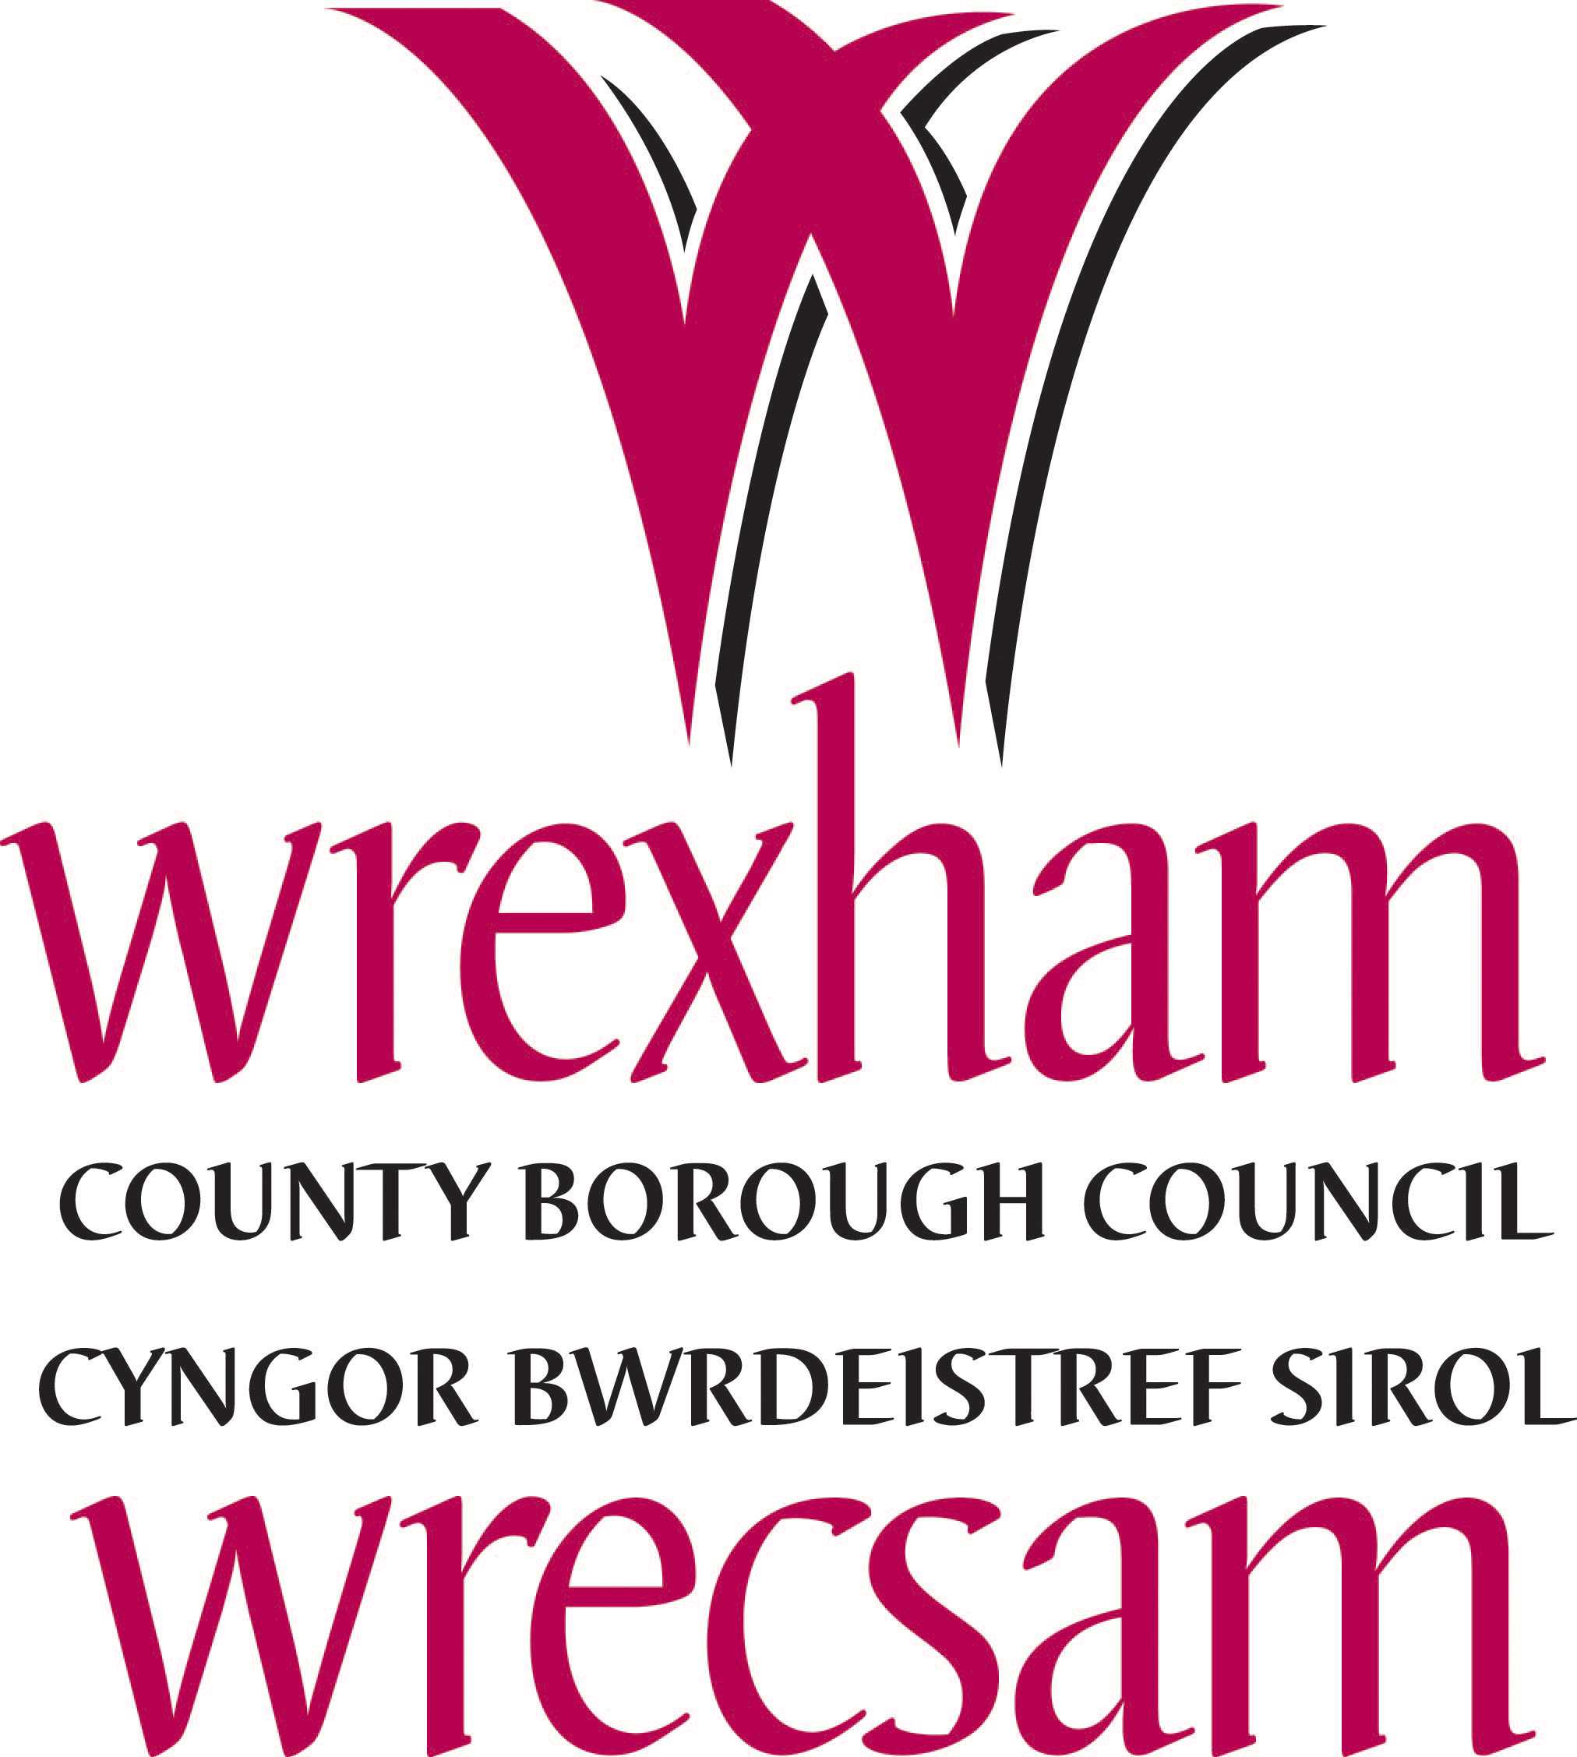

Ysgol Morgan Llwyd

Headteacher: Mr Iwan Owen-Ellis

Teaching Assistant Level 2

Salary – G04 Point 5-6
£16,808 - £17,074
Term time only
30hrs a week

Permanent
The Governors of Ysgol Morgan Llwyd wish to appoint a Level 2 Teaching Assistant to work in this happy and successful school.

The Governing body is passionate about education and is keen to continue on our journey of improvement. We are looking for an active and enthusiastic person who shares this vision:

A caring school that develops ambitious and capable learners, in an atmosphere where everyone is happy, safe and eager to learn.

The role will be within the mainstream of the school but the post holder will also work closely with the Learning Resource (Camau). The successful candidate will be expected to assist pupils with additional learning needs through combined learning methods, working closely with the Welsh and English departments. You will be expected to provide details and regular feedback on achievements, progress and behaviour.

The ability to speak Welsh for this position is essential.

For more information, contact Miss Rhian Owen, Business Manager owenr350@hwbcymru.net

To apply please download the application form and return it to Miss Rhian Owen, Business Manager, by email Owenr350@hwbcymru.net

Wrexham Council welcomes applications from qualified applicants regardless of race, gender, disability, sexuality, religious belief or age.

Note that all positions in schools are dependent on a higher DBS check (The Disclosure and Barring Service)

